Nepal College of Information Technology
Assessment
Fall 2009
Program: BE Time: 3 hrs
Semester: Fall FM: 100
Subject: Engineering Math-III PM: 50
Attempt ALL the questions.
The figures in the margin indicate full marks.

1. a) Prove that
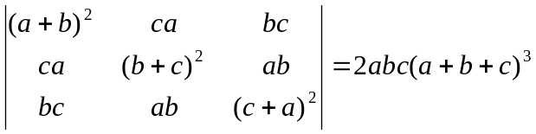 7
b) Check the consistency then solve the equation 8
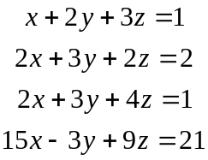 7

2. a) Check whether the vectors (1,1,1), (1,3,2), form a basis of R³ or not
8
b) Find eigen values and eigen vectors of the matrix. 7
A=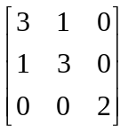
3. a) State and prove Comparision Test 7
OR
Find the interval, center and radius of convergence of the series
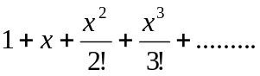
b) Expand tanx in Maclaurin's series and hence get the expansion of sec²x. 8
4. a) Define Fourier series. Find the Fourier series of the periodic function f(x) if
f(x) = 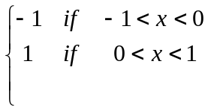 7
b) Find the Fourier series of f(x)=|x| for -π<x<π and hence show that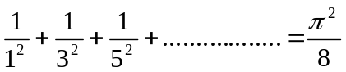 8
5. a) A particle moves on the curve x=2t², y=t²-4t, z=3t-5 where t is the time. Find the component of velocity and acceleration at time t=1 in the direction 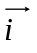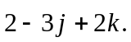 7
b) Show that the value under the integral sign 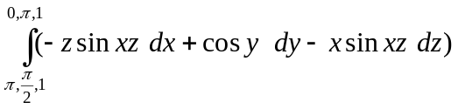 is exact and evaluate the integral.
6. a) State Green's theorem in a plane. Evaluate 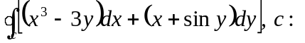the boundary of the triangle with vertices (0,0) (2,0), (0,4). 8
b) Find 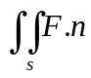 dA by using Gauss divergence theorem of 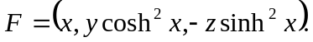 S is the ellipsoid 4x²+y²+9z²=36. 7
7. Attempt (Any five) 2*5
i) Check the linearly dependent and independent of the vectors (0,1,0), (0,0.1), (1,1,1)
ii) Find the period of 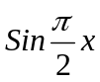
iii) If T: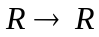 be defined by T(x)=x+4, is T a linear operator?
iv) Test the convergence and divergence of the series 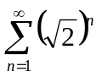
v) Find divergence of 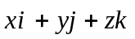
vi) If u=log(x²+y²z²) find curl(gradu)

